Handout from Award Winning Animation on Global Warming

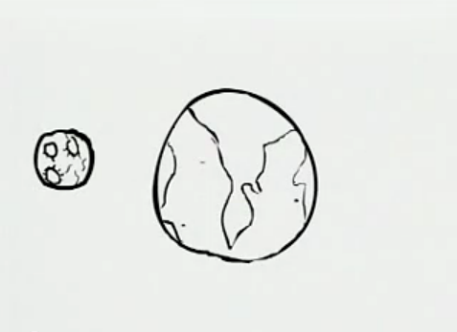
Caption:
____________________________________

____________________________________

____________________________________

____________________________________

____________________________________

________________________________________________

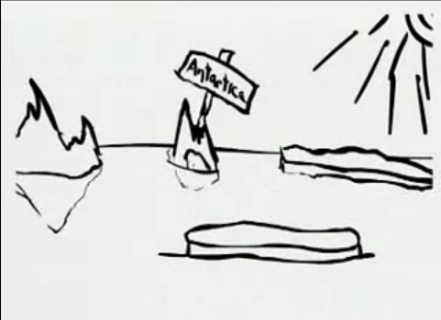
Caption:
____________________________________

____________________________________

____________________________________

____________________________________

____________________________________

________________________________________________

________________________________________________

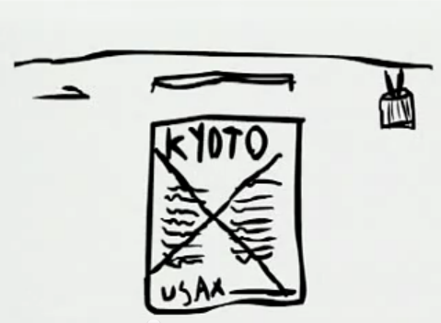
Caption:
____________________________________

____________________________________

____________________________________

____________________________________

____________________________________

________________________________________________

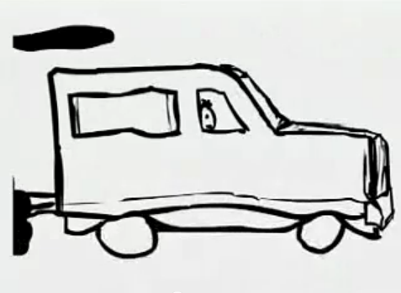
Caption:
____________________________________

____________________________________

____________________________________

____________________________________

____________________________________

________________________________________________

________________________________________________

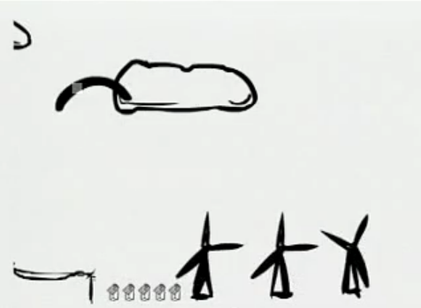
Caption:
____________________________________

____________________________________

____________________________________

____________________________________

____________________________________

________________________________________________

________________________________________________

Caption:
____________________________________

____________________________________

____________________________________

____________________________________

____________________________________

________________________________________________

________________________________________________
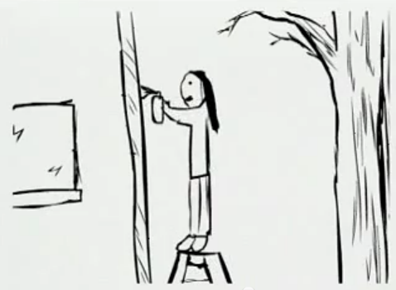

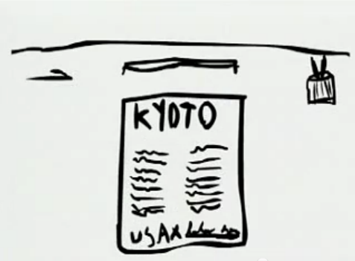
Caption:
____________________________________

____________________________________

____________________________________

____________________________________

____________________________________

Rules:
- Must use complete sentences
- Must ____ [Teacher: Insert grammar point here] _________
- Must use vocabulary from the list
- Must flow together as a story
- Each person must write his or her own captions -OR- Must work as a group… remember your roles!
- Must finish in 10 minutes

